# Guideline

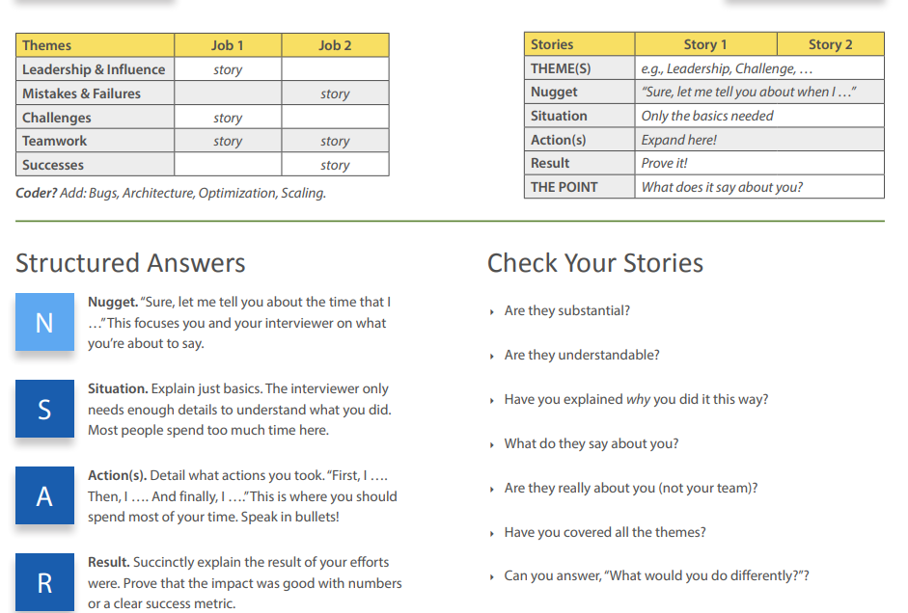

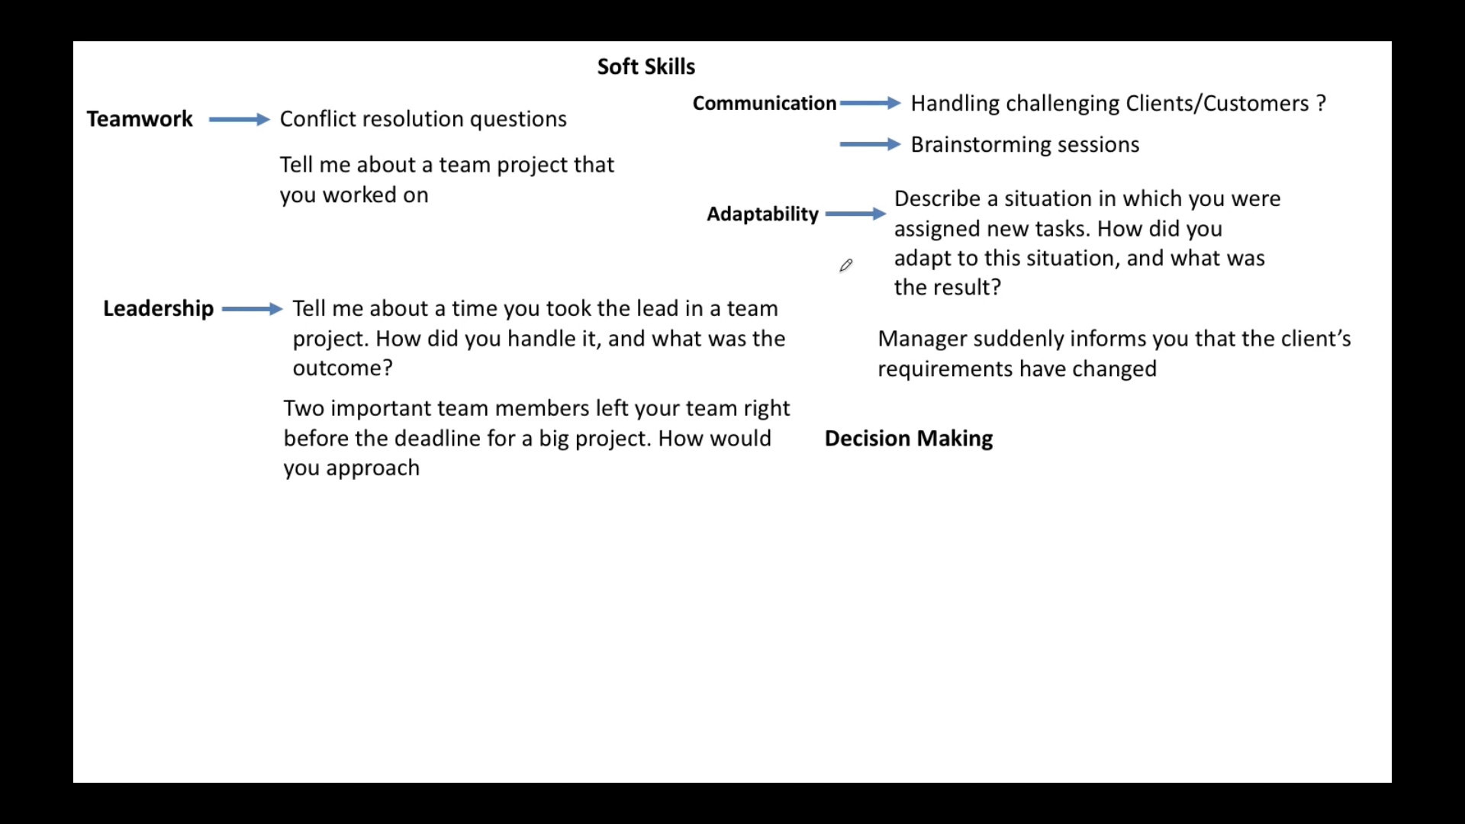

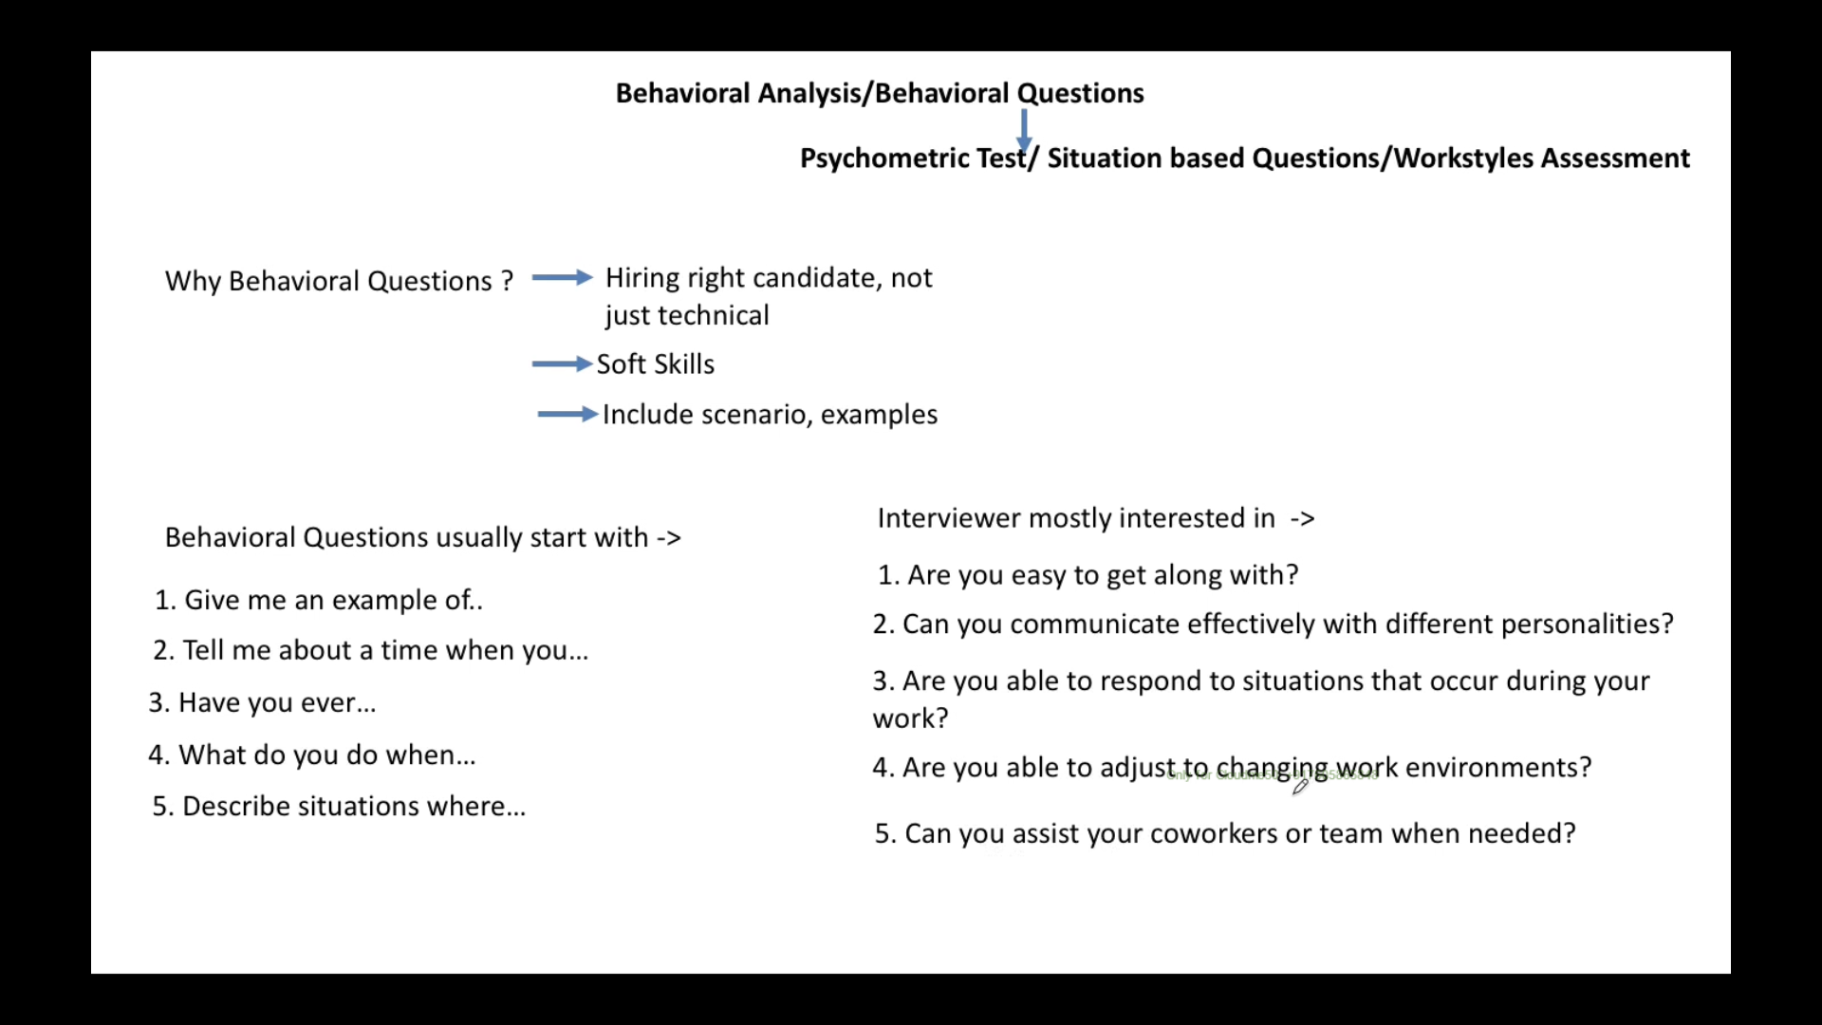

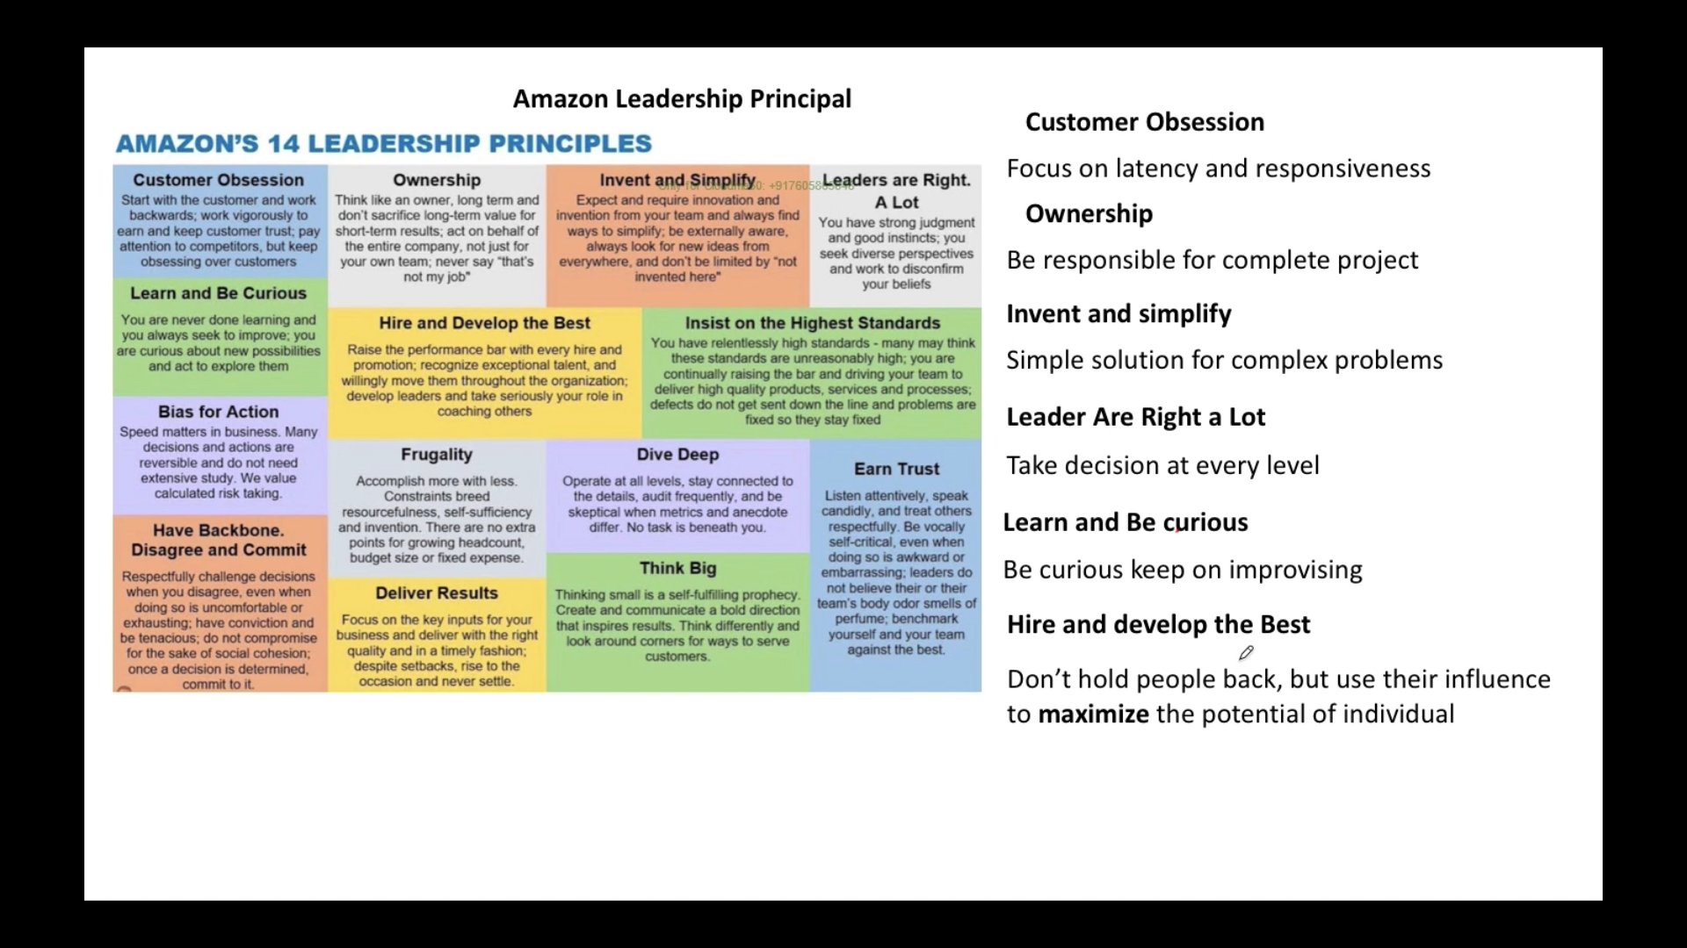

a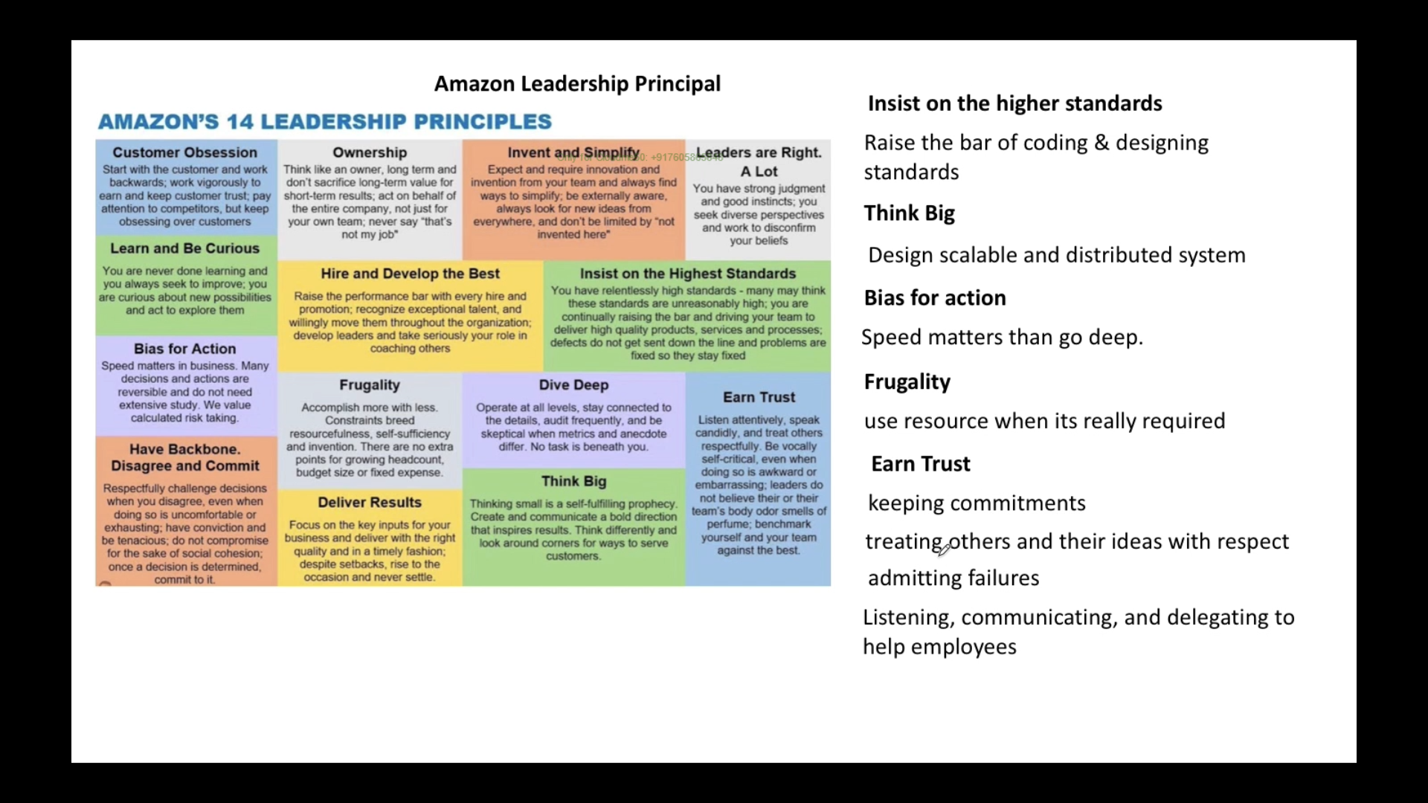

# Tell me about your self

* My self-Sujeet kumar.
* By academic – I have done Master in computer application
* I have working on .NET technology for long time along with AWS cloud
* I am very quick in learning and implementing efficiently

# Teamwork & conflict: Have you ever faced conflict with a co-worker? How did you resolve the situation? Or tell me about a time when you overcame a difficulty

## **Situation**

Normally I am very **friendly kinds of person** and **mingle well** with all sort of people.

But there was time I was working in one of the projects and a **Business Analyst was introduced** in team **and** I needed to work with him to refine and understand requirement and bring it to workable state for team and map it technically

I was not getting all requirement on time from his side; He even did not join meeting. Also, I was not getting doubt clarification on requirement due to all this project was missing the deadline.

## **Action.**

I took few of the steps.

First, I **setup one to one private meeting** with him and explained the whole scenario that how it effecting the project delivery if requirement is not given on time and doubt is not clarified on time.

After communication I found the root cause of the delay which I brought with my manager along with him.

Second, **before sending any meeting invite to him**, I started to check with him about suitable timing and his availability

**Third I went ahead and I made a thump rule and set a process** to follow where he also agreed to follow it.

## **Result**

Based on above action I took , it really helped us to be aligned with thumb rule and process to follow and since then we worked together on many challenging assignments and delivered on time.

## Option 2

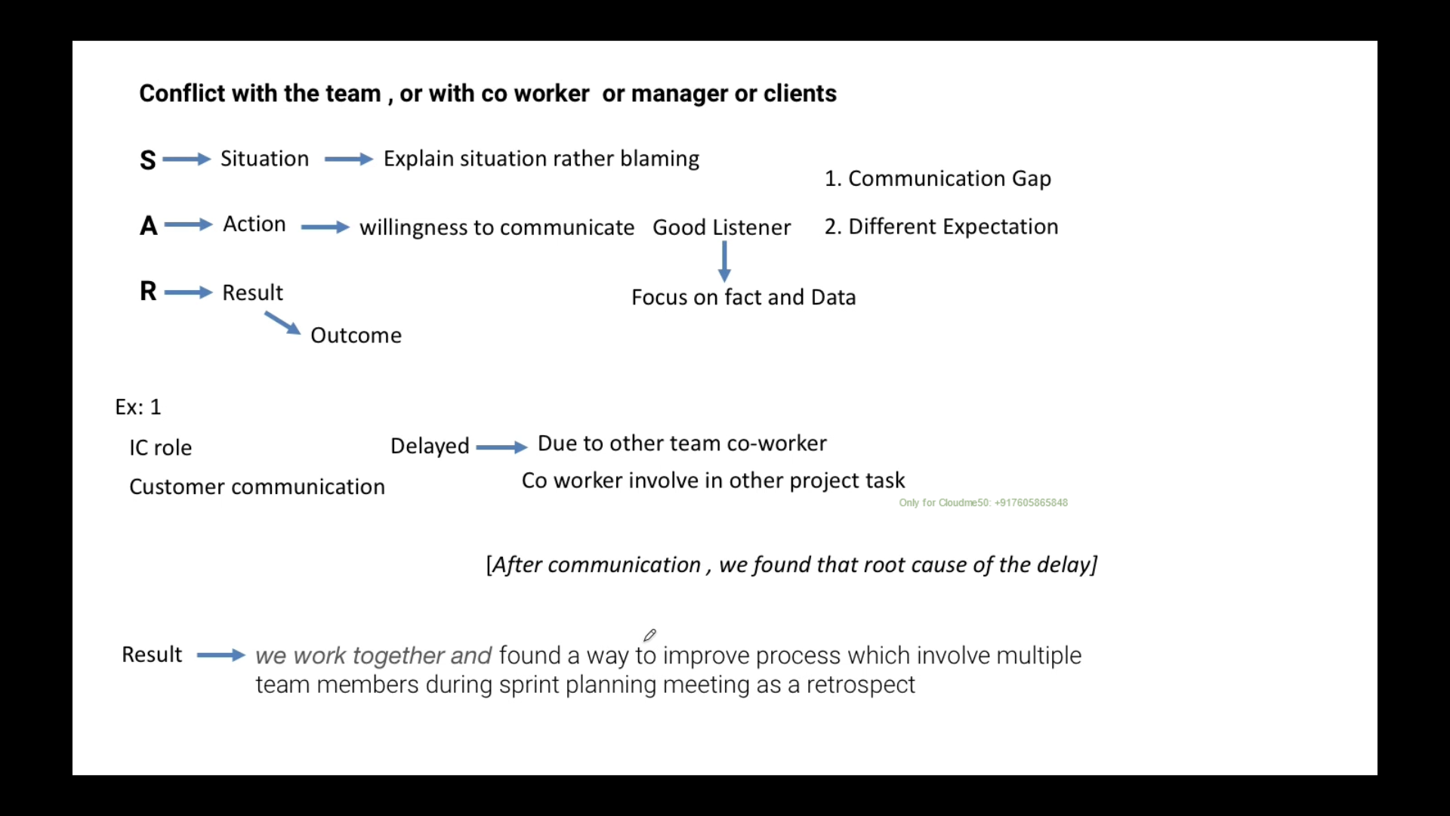

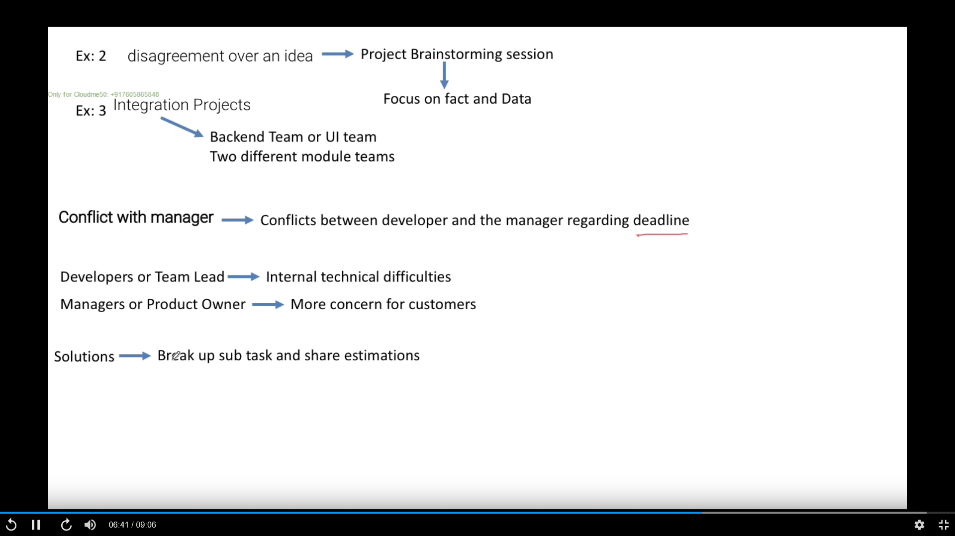

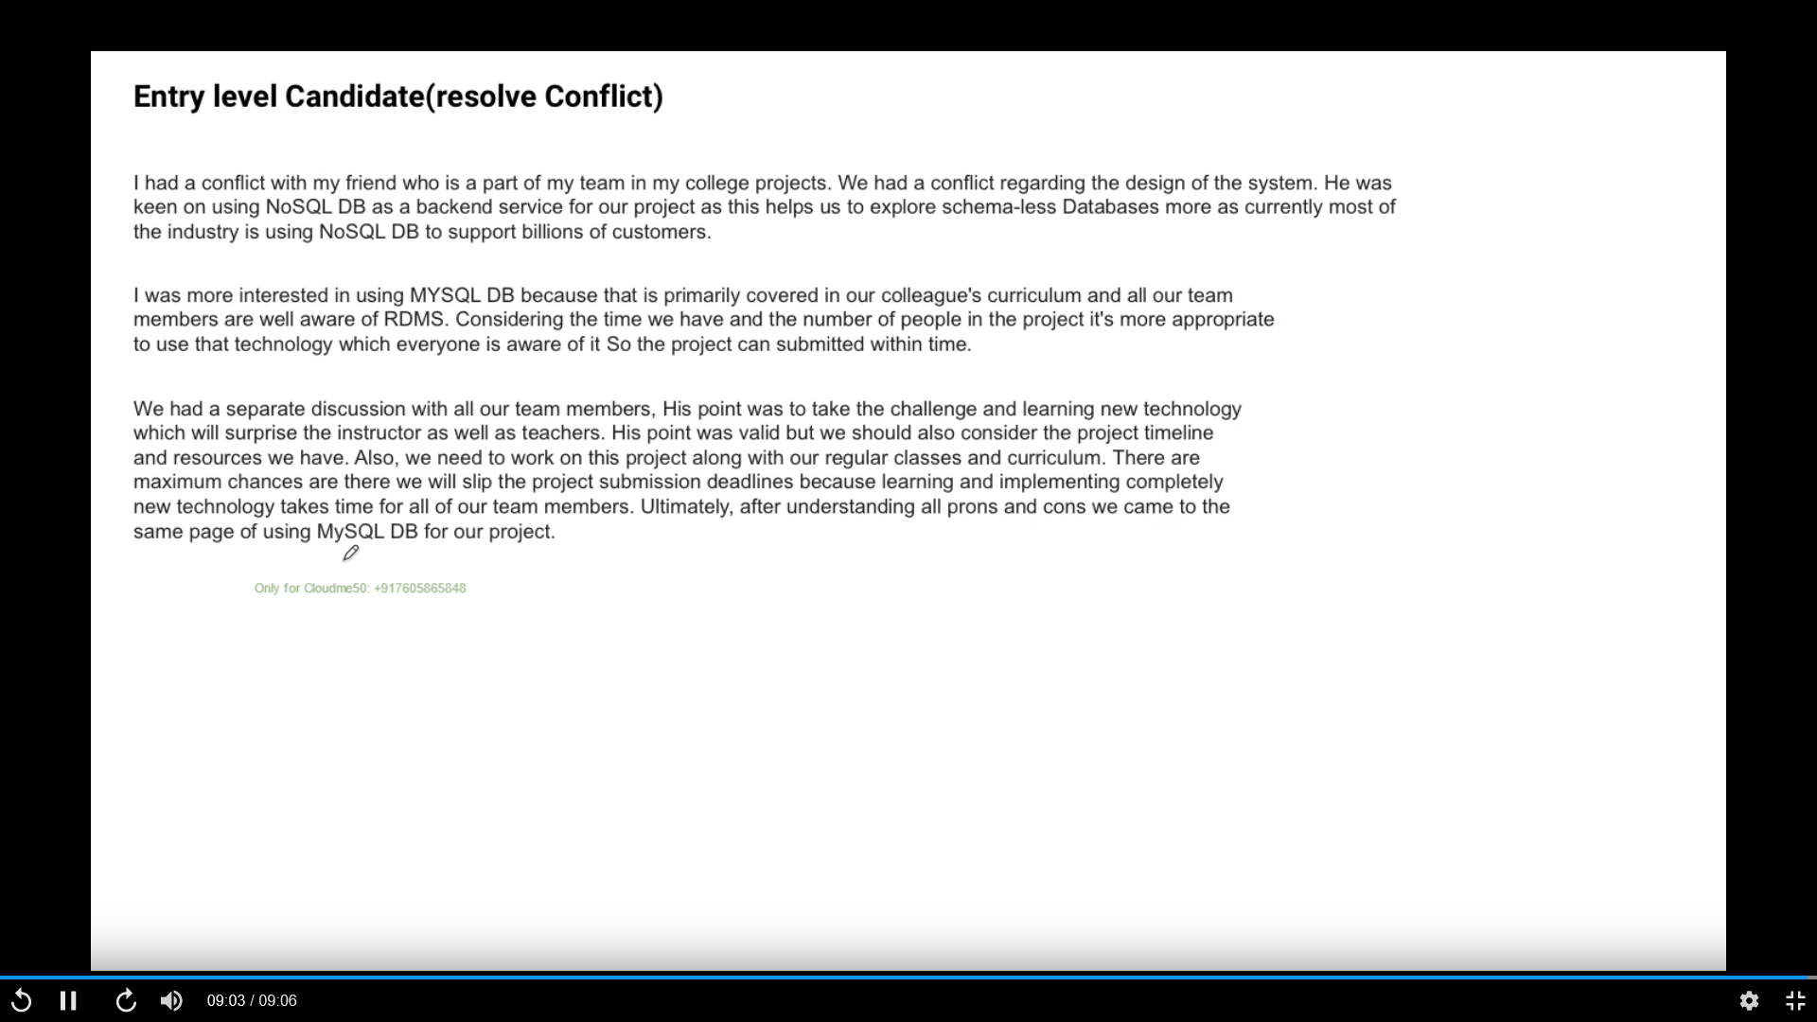

# Mistake & failure: Give me an example of a time you made a mistake at work

## **Situation**

Sure, let me tell you about when I was working in one of the projects with strict deadline.

I **took more work myself** to make sure everything is correct and quickly became overloaded that delayed the delivery by 2 days. I also **did not visualize the third-party dependency** and blocker.

## **Action.**

To resolve this, I took few steps.

First, I started to break down big fat requirement into smaller chunk and map it to doable deadline before committing to work.

I also started to **communicate**, **delegate** and **distribute** task among team member as per need and bandwidth.

I also started to bring third party dependency and blocker in my task ahead of time to resolve.

## **Result**

By doing so all committed work started to finish on time and since then I never miss any deadline and commitment

## Option 2

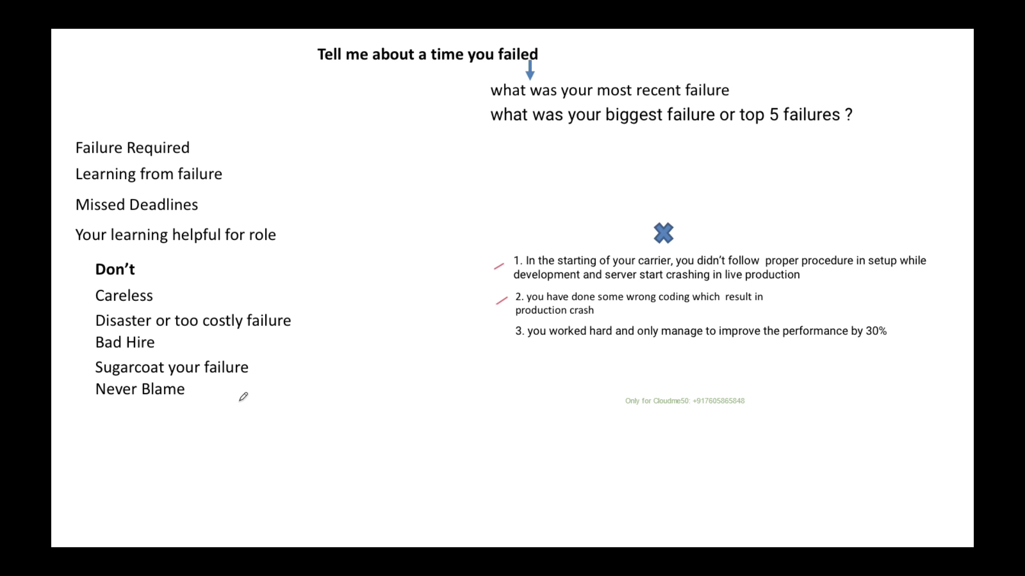

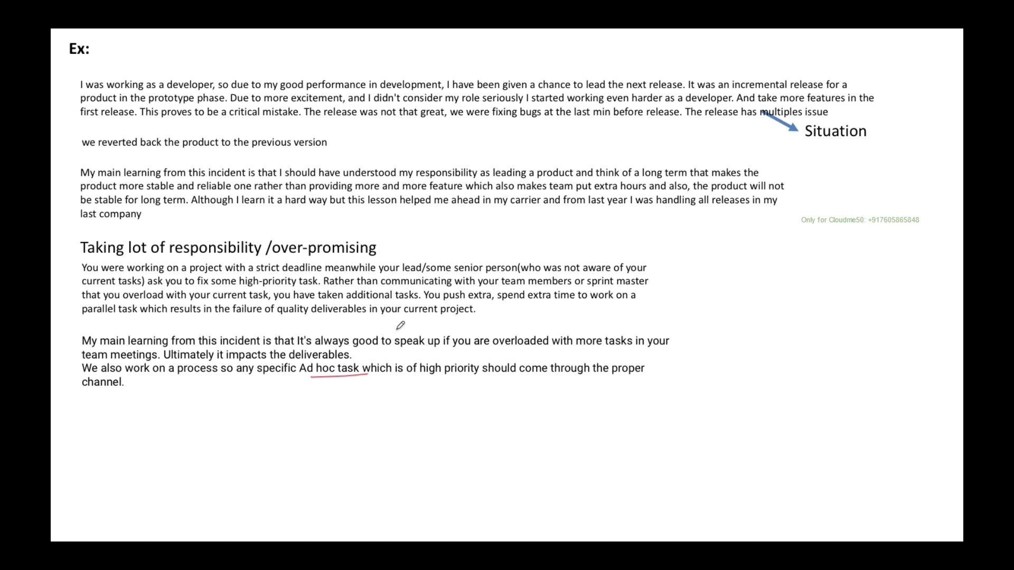

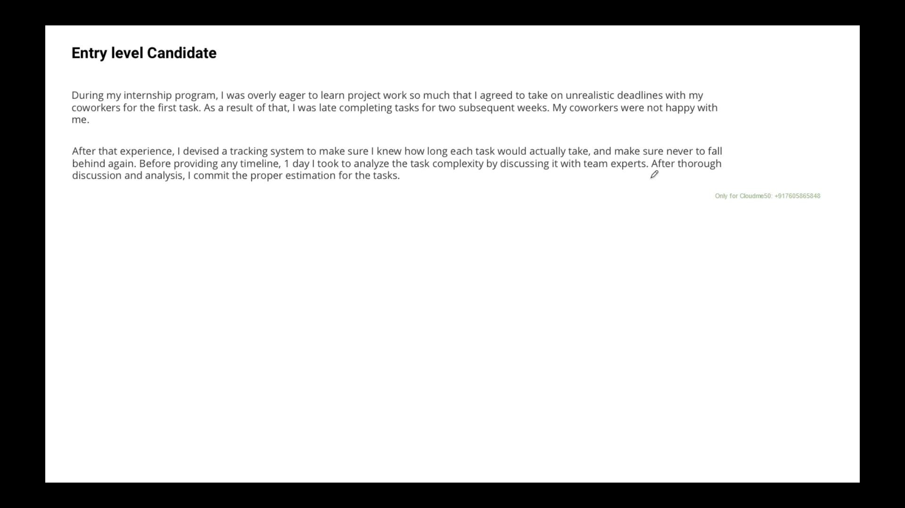

# Leadership & Influence theme:

**Hint**: leadership Key member left the project -Senior Developer to TEAM LEAD, directly became front to stack holders

**Hint**: influence to use aws sns

## **Situation**

Sure, let me tell you about when I was working in one of the projects as senior Developer and key member who was leading the team left and we had project delivery and deadline very near.

## **Action.**

So, my manager promoted me to lead the team and I took it proactively.

**First, I set up a team** meeting to understand how and where I can help the team to meet deadline. After meeting I got to know few of obstacle, dependency on other that few of the team member was facing.

I went ahead and talked project manager of another team to help us what my team need and ensured that my team have all that they need to complete the task.

I also went ahead and started bi-weekly cross module KT, Skill gap training. I also personally mentored and coached few candidates so that they can work efficiently.

## **Result**

By doing so we successfully met deadline and deployed in production and I became first person in whole account that has first-hand opportunity to lead in any new initiative. For same reason I was awarded with some GEMS and recognition.

# Challenges:

**Hint**: Microservice was in consistent to deliver message to another microservice and it was bigger issue

## **Situation**

Sure, let me tell you about when I was working in one of the projects

## **Action.**

To resolve this, I took few steps.

## **Result**

By doing so

# Communication:

**Hint**: Senior Developer to TEAM LEAD, directly became front to stack holders

## **Situation**

Sure, let me tell you about when I was working in one of the projects

## **Action.**

To resolve this, I took few steps.

## **Result**

By doing so

# Adaptability:

**Hint**: Senior Developer to TEAM LEAD, directly became front to stack holders

## **Situation**

Sure, let me tell you about when I was working in one of the projects

## **Action.**

To resolve this, I took few steps.

## **Result**

By doing so

# Biggest technical mistake I made – Feature flag - Devops

**Hint**: Feature flag

## **Situation**

Sure, let me tell you about when I was working in one of the projects

## **Action.**

To resolve this, I took few steps.

## **Result**

By doing so

Experience professional –

Many Team working on many module. I pushed code without feature flag

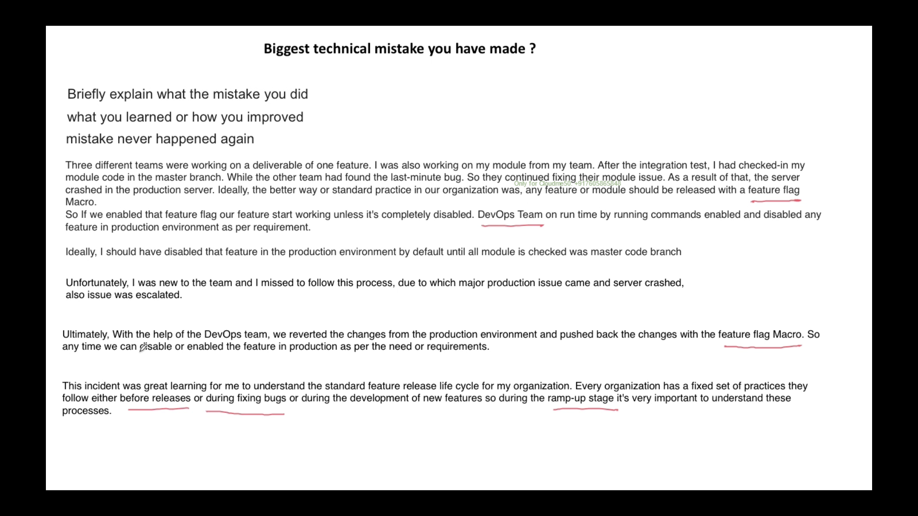

College project

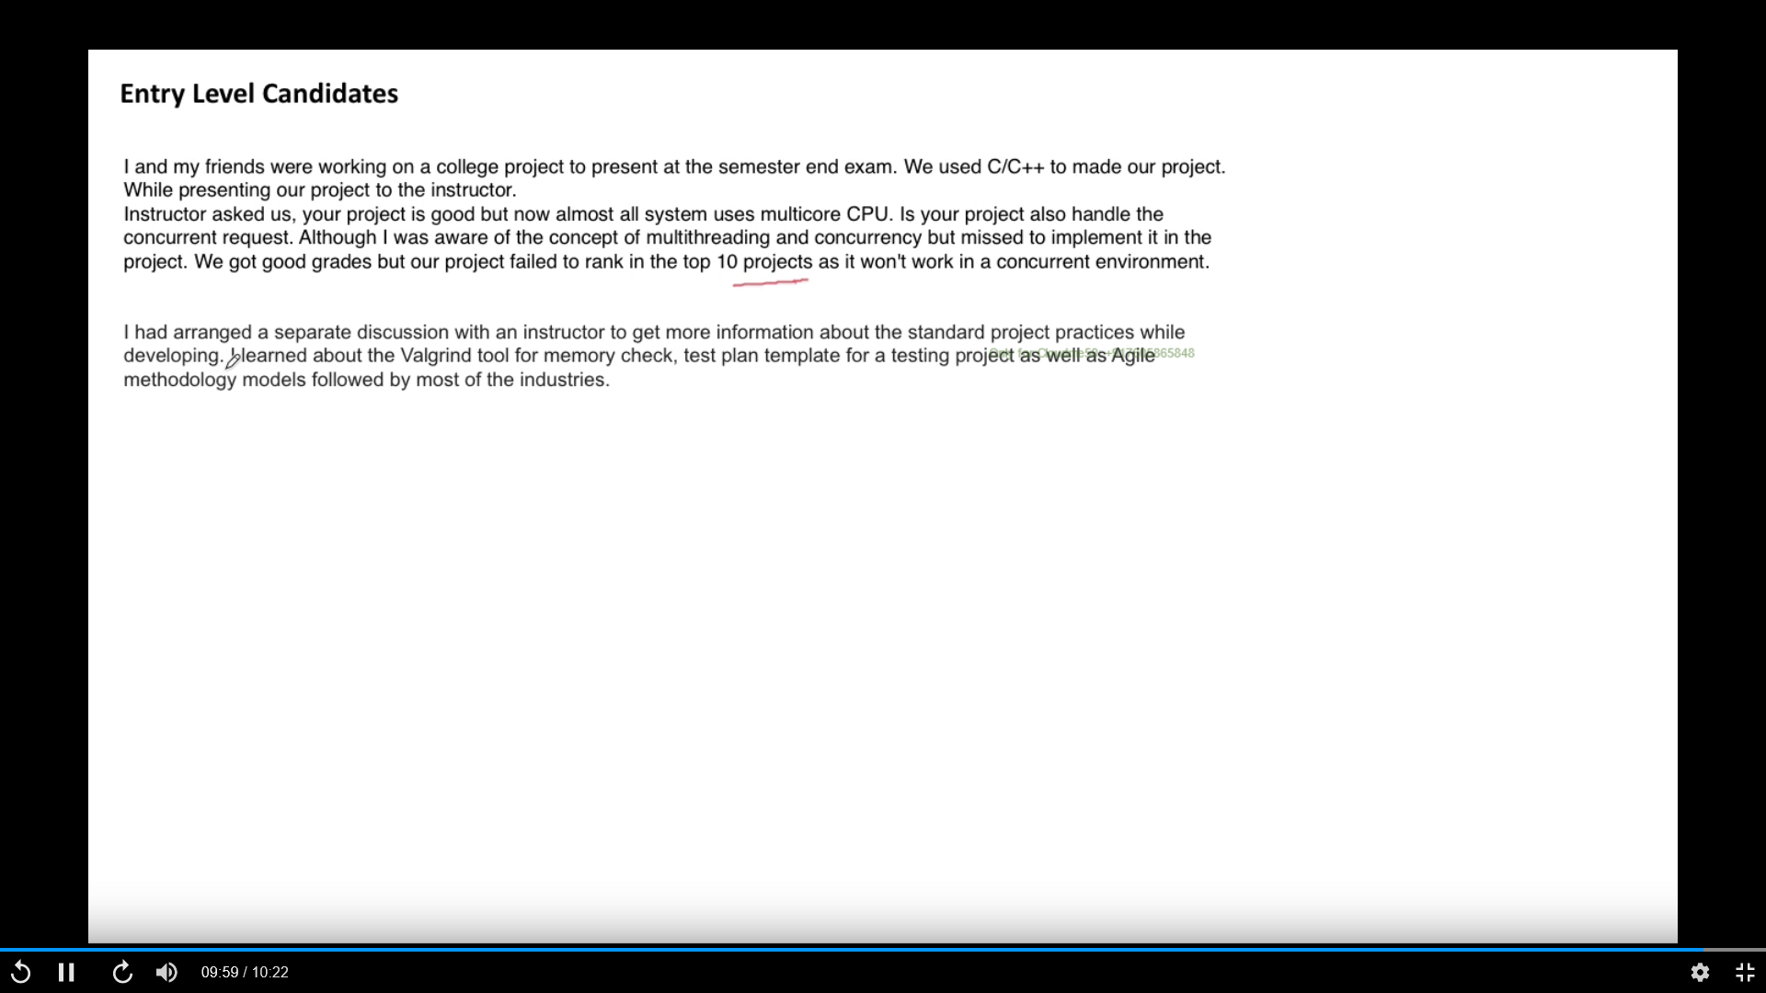

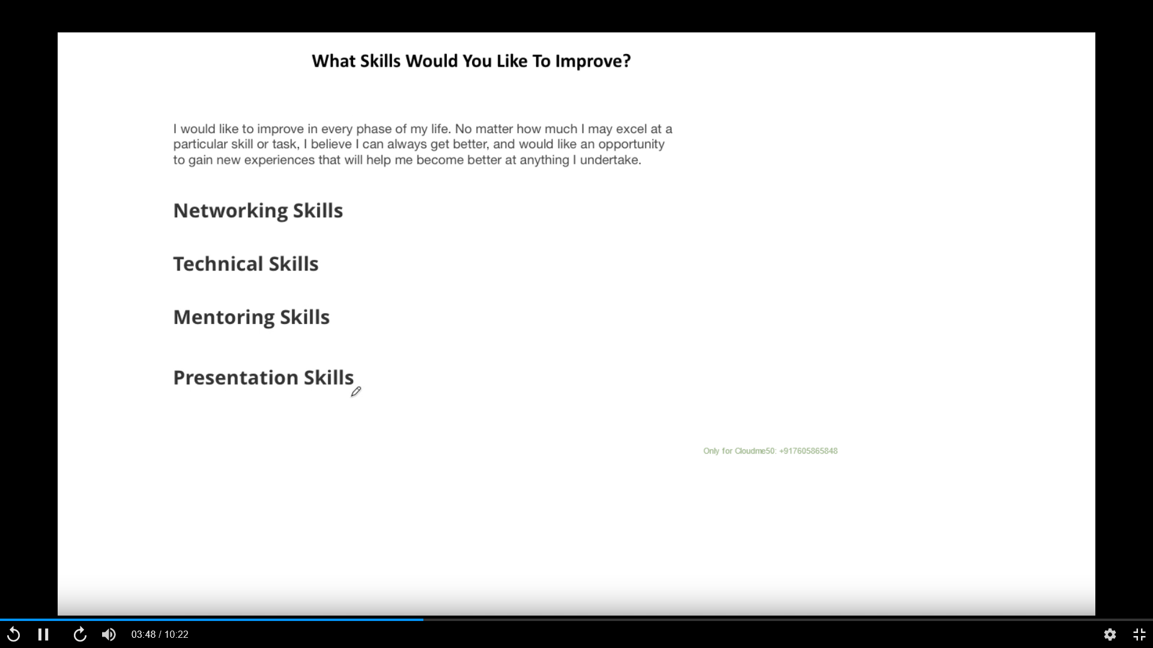

# Situation when you had solved a very difficult problem in project

**Hint**: Resilience Lambda to make

## **Situation**

Sure, let me tell you about when I was working in one of the projects

## **Action.**

To resolve this, I took few steps.

## **Result**

By doing so

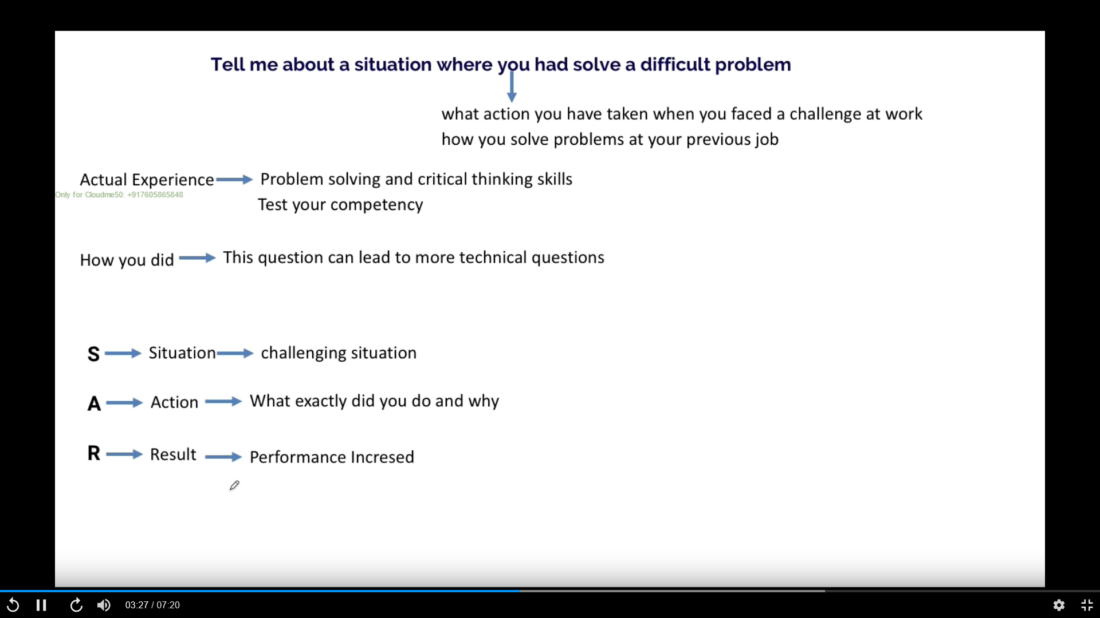

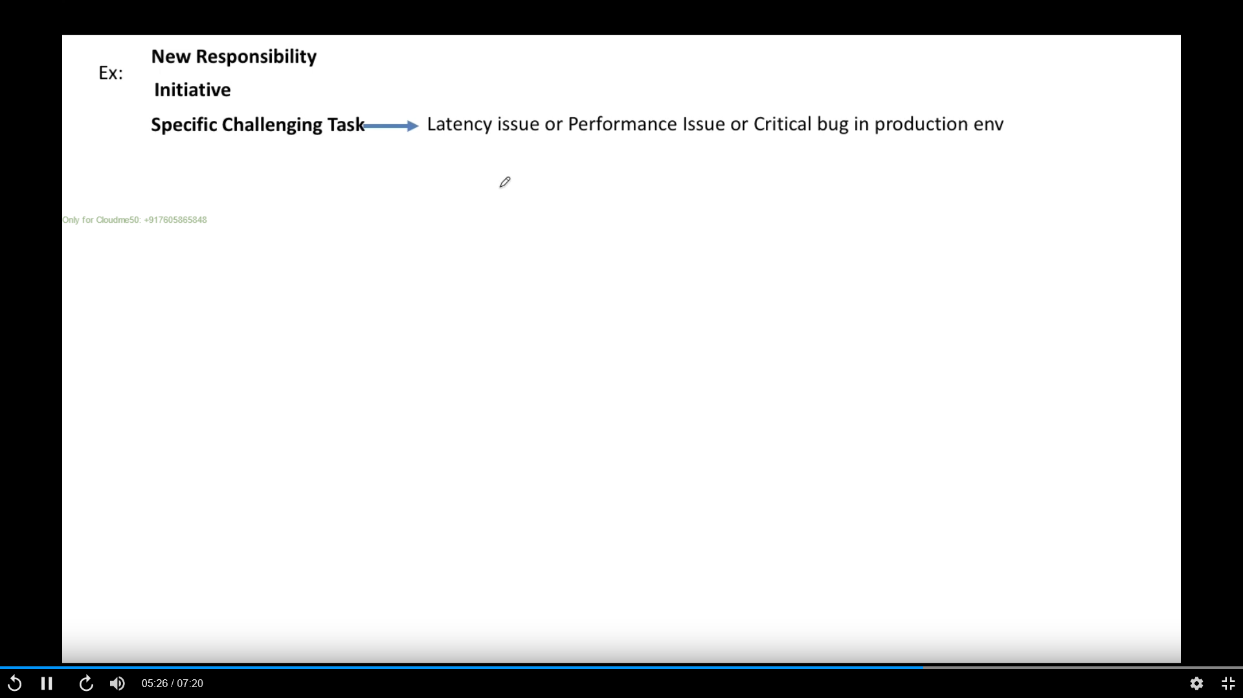

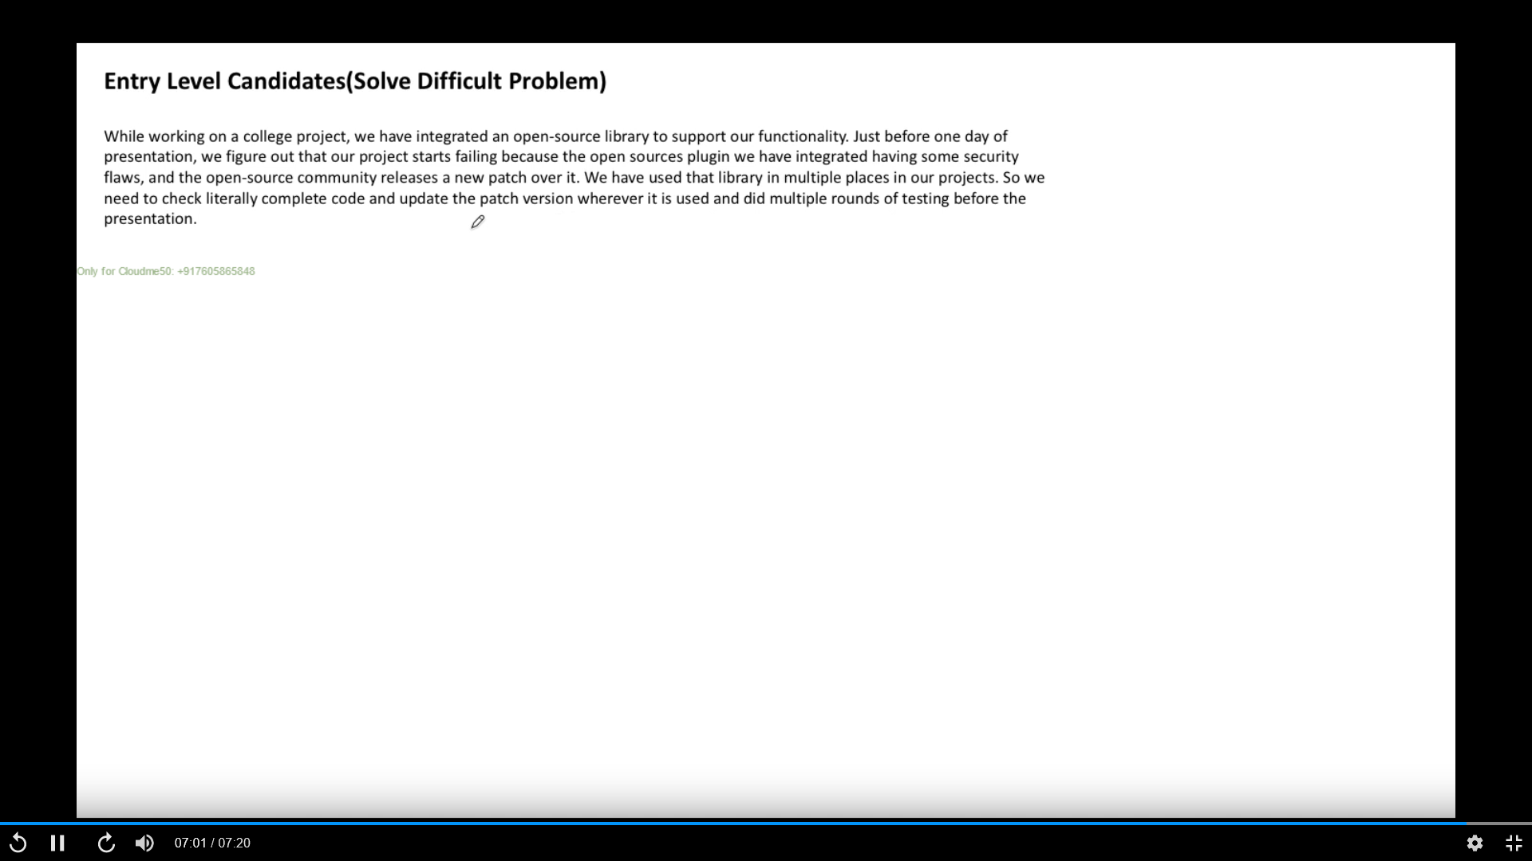

# Why your CGPA is not high,

# when you have taken initiative in a project

**Hint**: AWS SNS – Microservice communication – Team opposed the idea but I given fact and they were agreeing

**Hint**: Weekly **knowledge sharing** on different feature developed, Cross module knowledge sharing, Onboarding process documented and put on central repository

## **Situation**

Sure, let me tell you about when I was working in one of the projects

## **Action.**

To resolve this, I took few steps.

## **Result**

By doing so

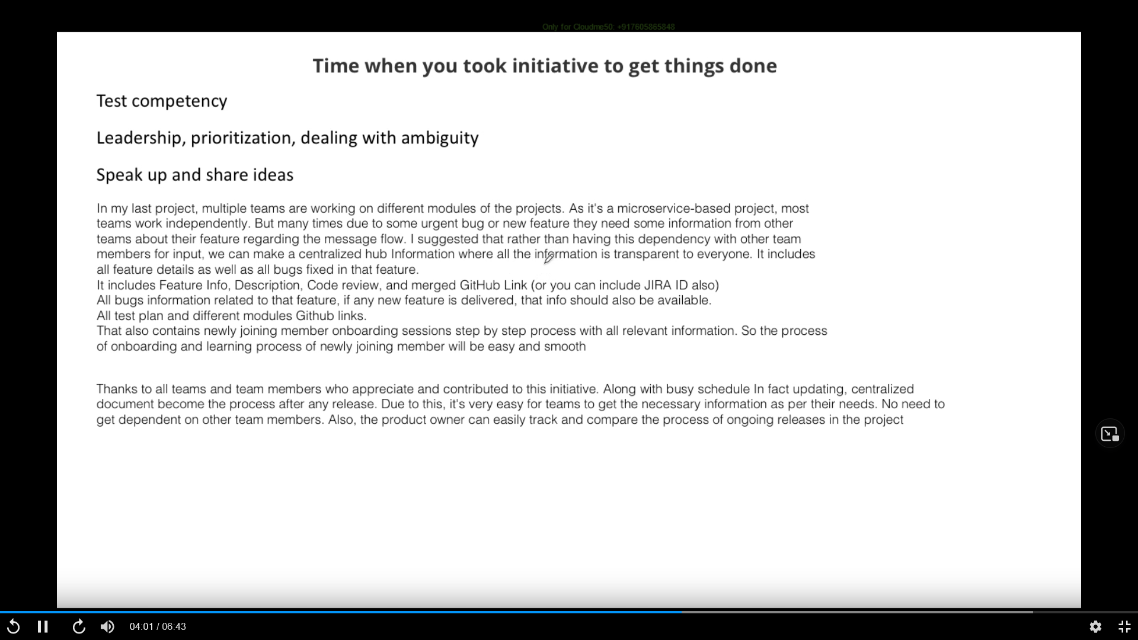

# Time when you have failed to meet customer deadline in project

HINT – Mistake and Failure || critical bug in last project || Extra buffer time – also train another person in department

**Take first two paragraph for your answer**

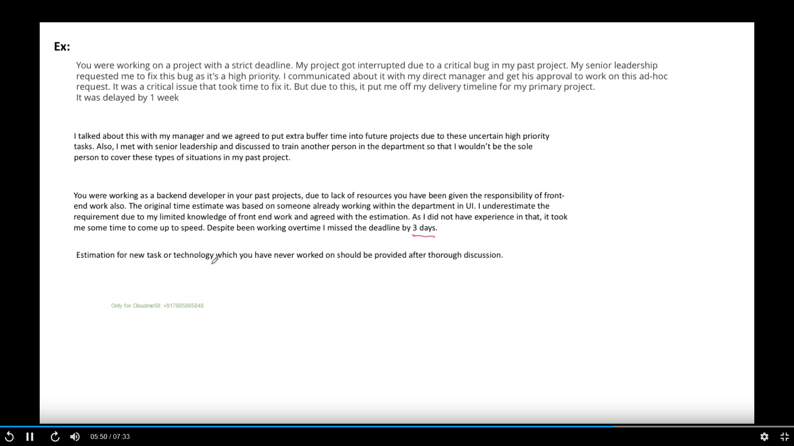

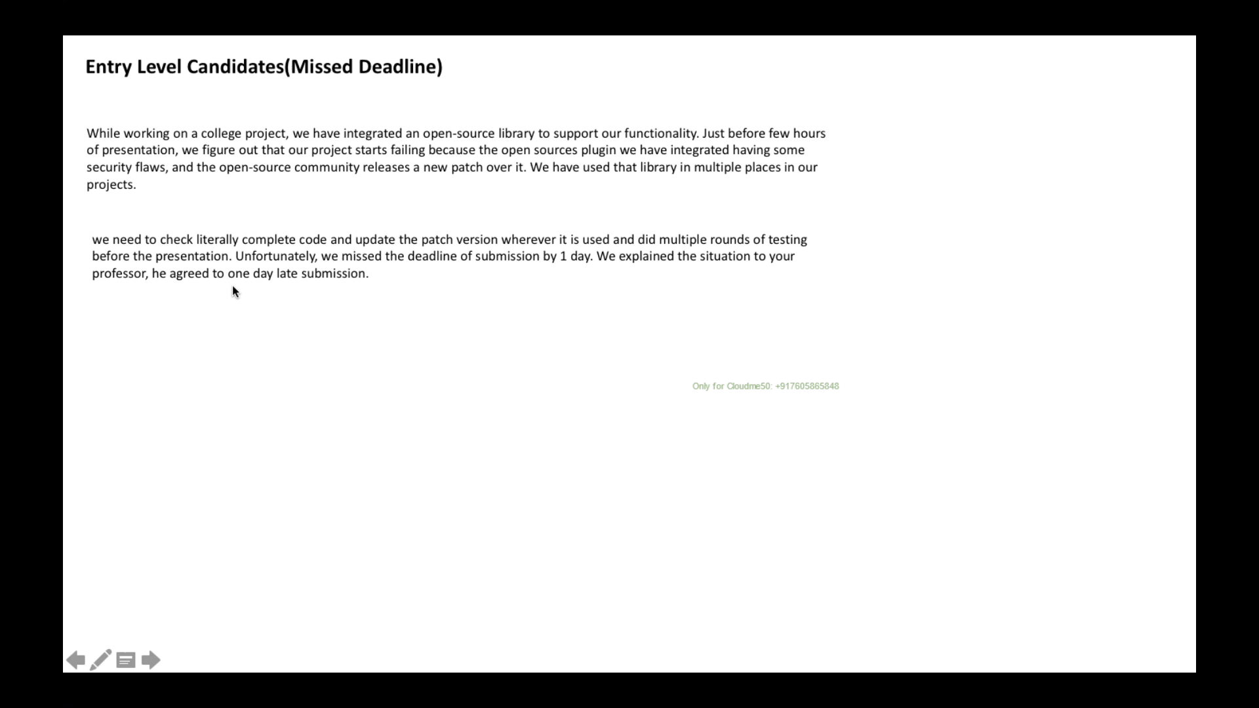

# What is your greatest achievement in a project?

HINT –

1. Joined as Individuals contributor but based on my performance I promoted to lead the entire team
2. Designed Microservice architecture based application and delivered project on time .

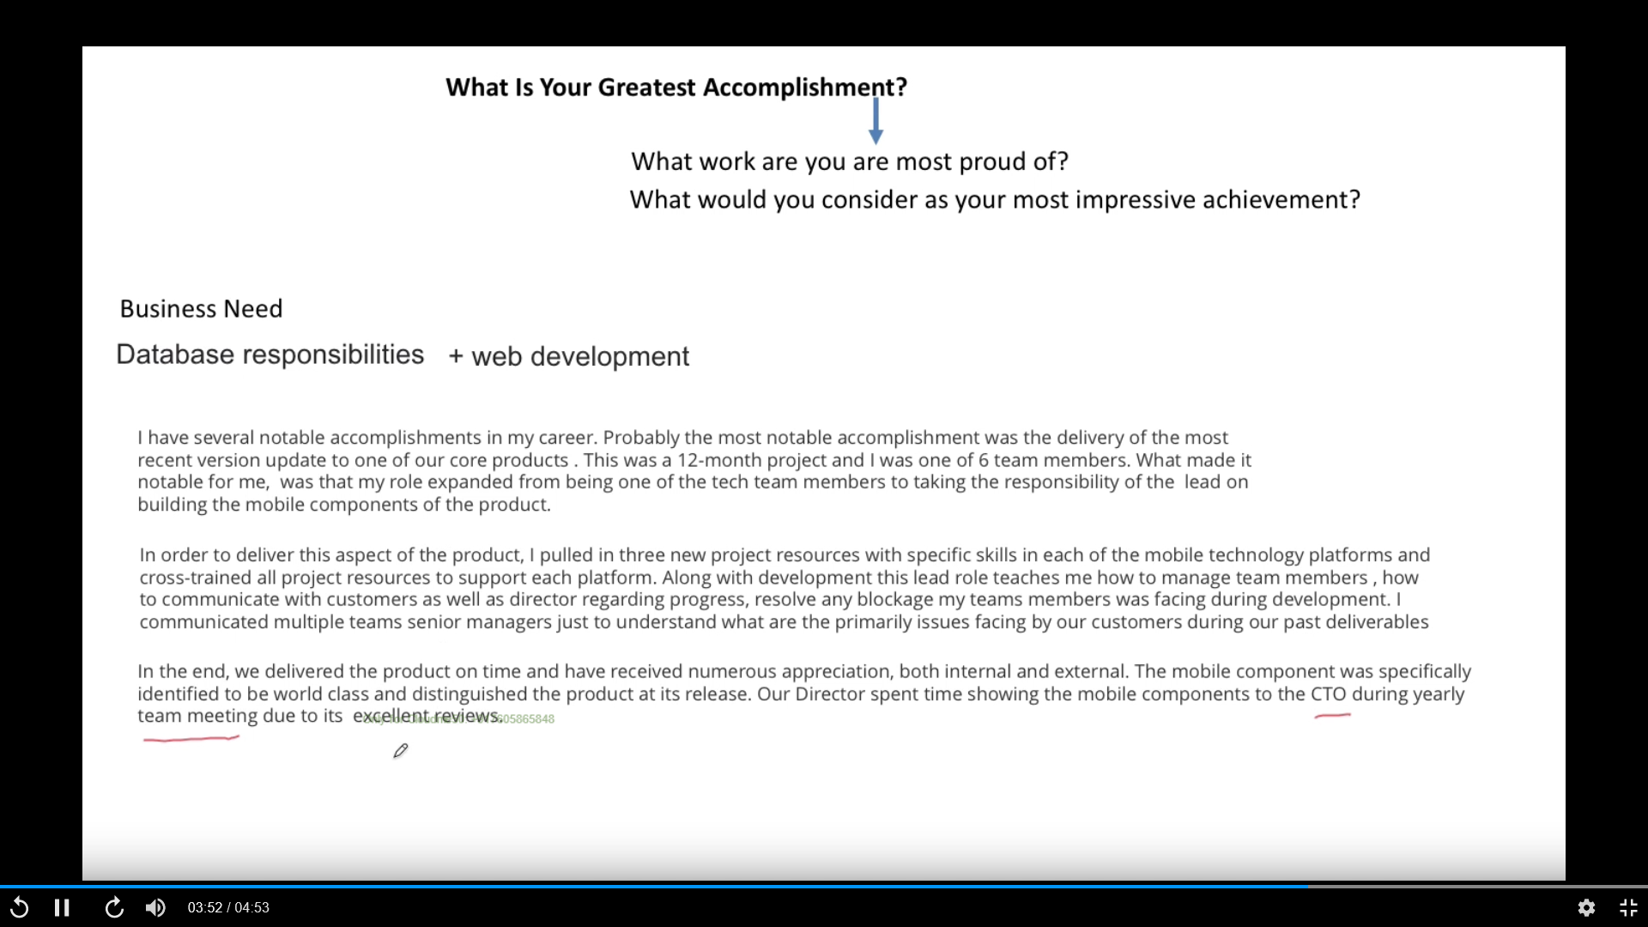

Fresher

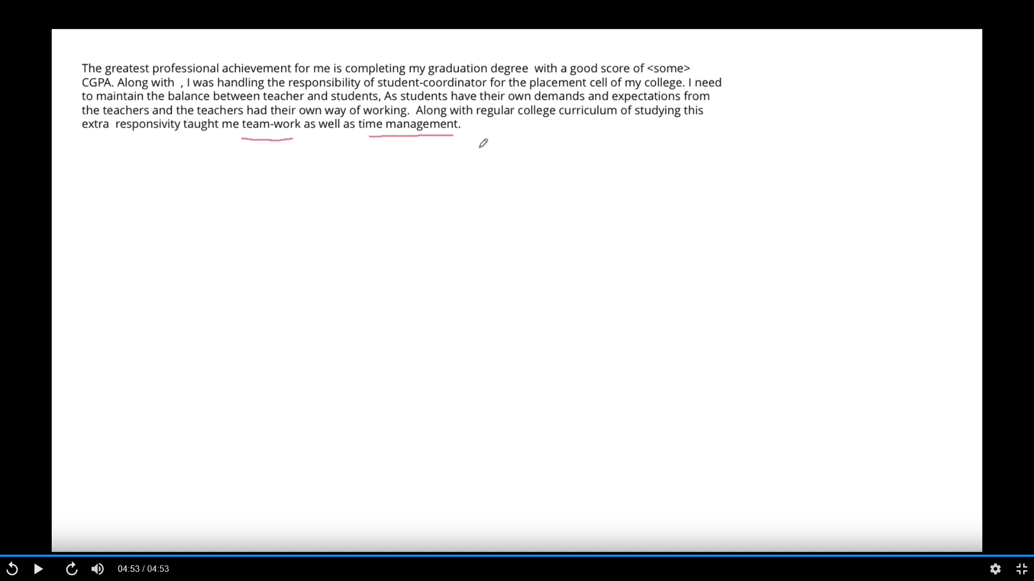

# Time when you successfully meet the tight deadline of a project

HINT –

1. Working in one module – TP
2. My colleagues in other module become sick and went on leave
3. My manager told to take other module ownership as well
4. Borrow some resource from other project have less work
5. How to handle parallel task – manage resource effectively , Prioritise task .

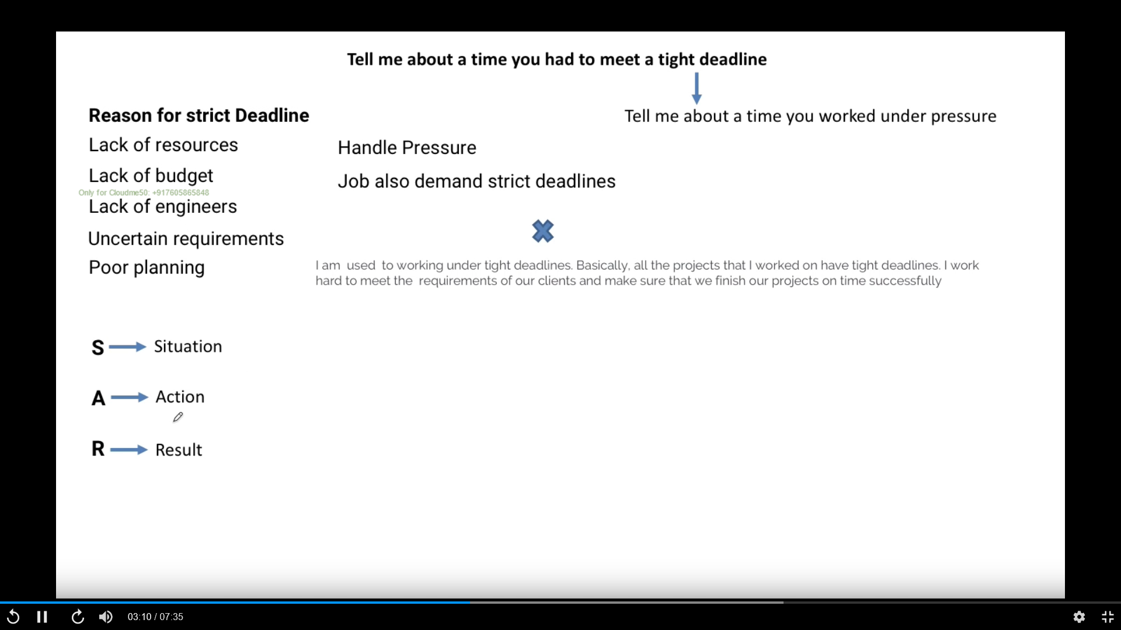

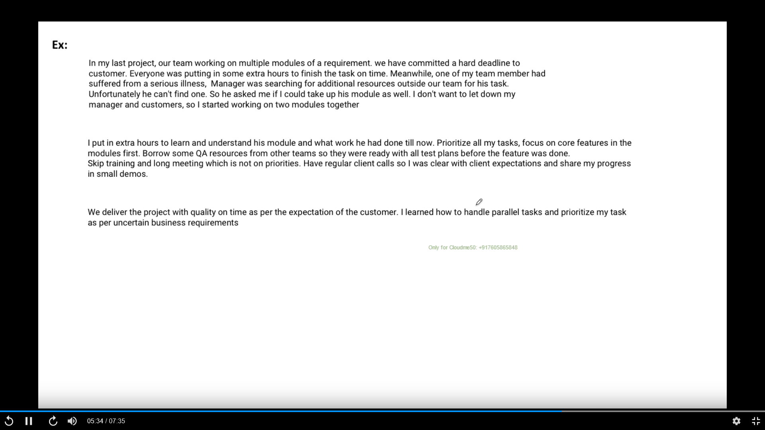

Fresher

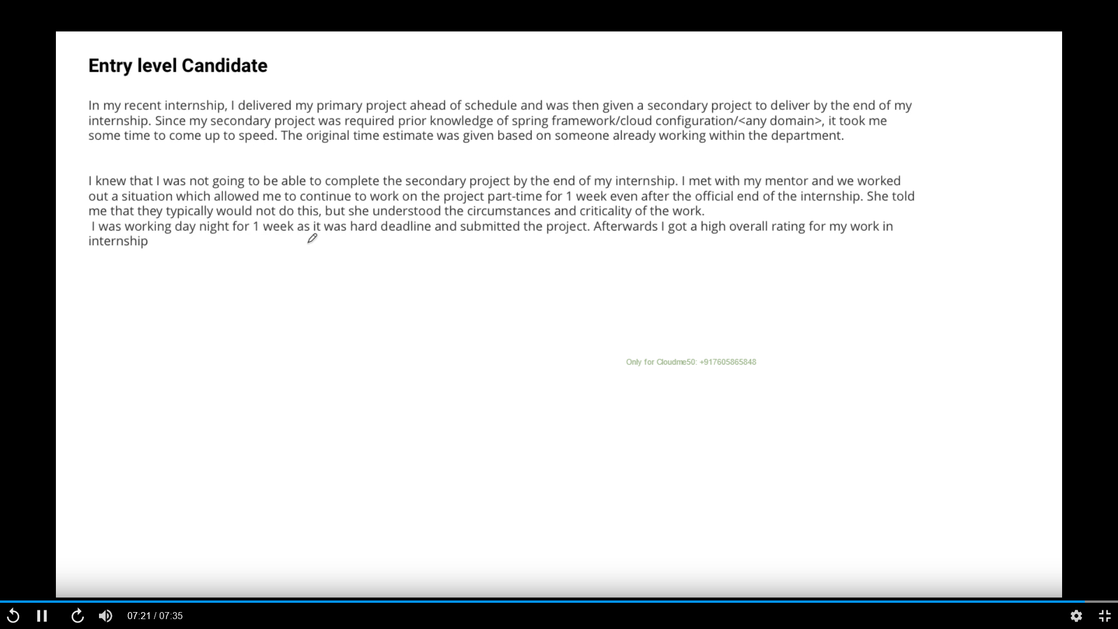

# Tell me the time when you regret your decision in a project deliverable

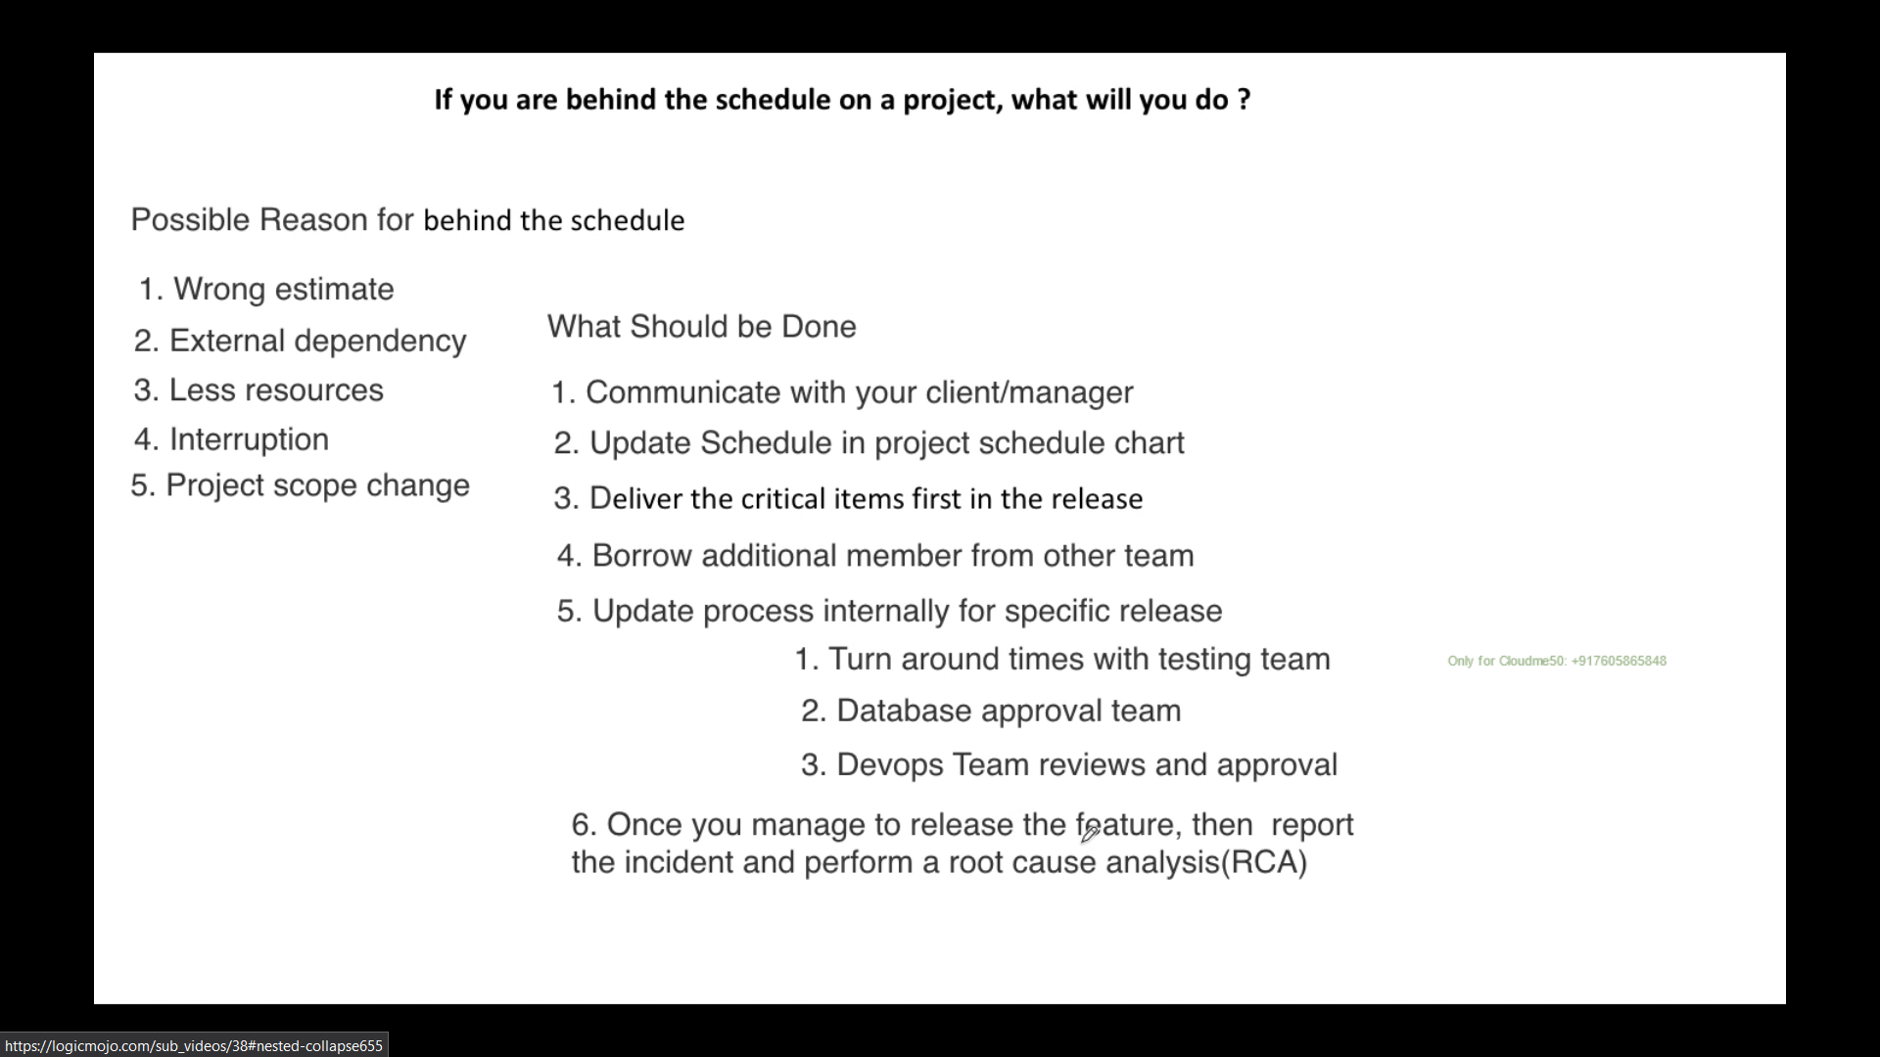

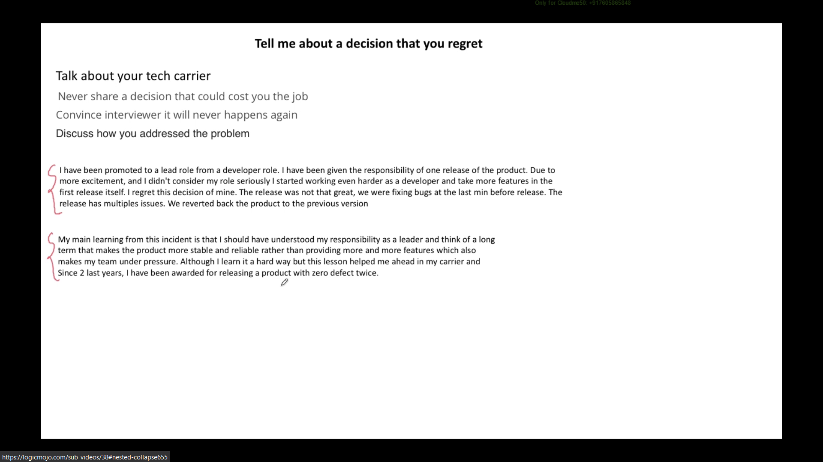

# =====Commonly Asked Question ===============================

# How you find resource that u need to work – John

Hint – Drools

**Situation –**

Sure, let me tell you about when I was working in one of the projects and I needed to modify one Rule engine logic but no clue about this rule engine module.

**Action**

**First**, I tried to find related document in **company document repository to find if there is any KT recorded video or any related document have** and found few docs **then** I tried to find who **else has work previously on this module** but found that he is no longer in company so Went through all document that I found in document repository.

I also looked for help from **online official documentation** and **online** **official forum.**

**Result**

Finally, I was able to find all required resources and fact that I need to modify the rule engine and I successfully complete my task and deployed in production.

# How do you deal with co-workers that don’t cooperate or can’t contribute enough?

**Hint**: Not able to complete task, set up meeting-asked why you doing – mentored coaching

## **Situation**

Sure, I was working in one of the projects and I had to show one demo to all stakeholder and one of the team members was not able to complete task on time that use to impact whole team velocity.

## **Action.**

First, I set up one private meeting conversion and I asked how I can help him to contribute and complete task on time.

After conversation, I came to know that he is **lacking domain knowledge**, **Project understanding** and **lacking some of the technical skill**.

Then I setup multiple bi-weekly meeting to provide him required domain knowledge, given project walk through and also given training on technology so that he can do his work.

I also extended my help and asked him that he can ask me whenever he need to understand and need any help to execute his work.

I also initiated knowledge transferred session across project to all member where all had to participate and share his expertise and document it for future reference.

## **Result**

By doing so he catched up well and started to contribute and was able to complete task on time. He also started to take extra task after his task completion

# Tell me about a time when you went above and beyond your duties for a job or task.

**Situation**

In my last project, all task was distributed among team member but in the middle of sprint one production issue started to come where one microservice sometime was not able to publish/send data to another microservice due to that there was a major impact.

Customer was very unhappy of instability of system and wanted fix immediately in the same ongoing sprint.

**Action**

I had already many things in my plate for my current sprint but **I took the ownership** and extended many hours to **analyse, debug, check the server log and found the root cause**.

Finally, I designed and developed a resilience tool using AWS serverless Lambda that re process failed event/data/ message to other microservice.

**Result**

As a result, application and system become stable and customer was happy. I was awarded for same

# Tell me about a time when you were faced with a challenging situation. How did you solve it?

**Hint**: Microservice was in consistent to deliver message to another microservice and it was bigger issue

# Do you usually set goals at work? If yes, could you give me an example of a goal you had and how you achieved it?

* Break down big chunk into smaller chunk – that help to estimate cost wise and effort wise, different person can work on many tasks at same time. Track
  1. understand my point of understanding and idea to resolve the issue

# Tell me about a time when you handled the pressure well.

* 1. Developer to TEAM lead
  2. Manage stockholder

# Was there a time when you had to be very strategic in order to meet a goal? – John

* 1. Developer to TEAM lead
  2. Manage stackholder
  3. Break down task

# Give me an example of a situation when you showed initiative and took charge of a situation.

**Hint**: Drools hand over to business so that they can create

## **Situation**

Sure, let me tell you about when I was working in one of the projects

## **Action.**

To resolve this, I took few steps.

## **Result**

By doing so

# Did you ever have to correct one of your superiors when they were wrong? How did you approach that situation?

* 1. I take that offline and talk one to one with pros and cons of solution suggested by supervisor and any better idea I have

# Have you ever had to work under a tight deadline?

* 1. Always

# Tell me about a time when a client was asking for the impossible. How did you explain and communicate this to them?

* 1. Break down the task that is easy to understand and cane estimated in time and can be visualize
  2. Show the resource bandwidth and task complexity
  3. Help to make understand that quality will be compromised
  4. Try to come with MVP minimum viable product
  5. A trust Relationship is very important here that help to win client confidence

# Give me an example of a time when you didn’t meet a client’s expectations. How did you deal with the situation?

* 1. Inform well in advance and communicate if any uncertainty
  2. Show what caused to delay, was this communicated effectively on time
  3. Put genuine effort to come with alternative plan in minim time

# Is there a situation you think you could’ve handled better or differently?

# How do you adapt to sudden changes in the workplace? Could you give me an example?

* 1. I am very much adaptable in term of people, in term of technology, in term process because I believe that flexibility is the only way to grow
  2. First try to understand and learn new process and adapt slowly to it

# What was the first job you ever had? Do you remember how you adapted and learned the ropes?

* 1. I joined and just my senior left in few days

# Tell me about a time when you had to think on your feet in order to deal with a situation.

* 1. I joined and just my senior left in few days

# Sometimes employers put too much on their employees’ plates. Was there a time when you were overwhelmed with work? How did you handle the situation?

* 1. Prioritize, Breaking down big chunk into smaller chunk, MVP

# Tell me about a time when you had the liberty to be creative with your work. Was it exciting or difficult for you?

* 1. This is where I come excellent and put something new on table. This is what excite me more and make me go getter.

# Give me an example of a time when you and your team had opposing views on an issue. How did you persuade them to go with your decision?

* I believe in open discussion and very much to accept better and effective idea. If there is opposing view then I can show this to someone who he trust and believe and put the presentation on table